Arnaud DUCLAP

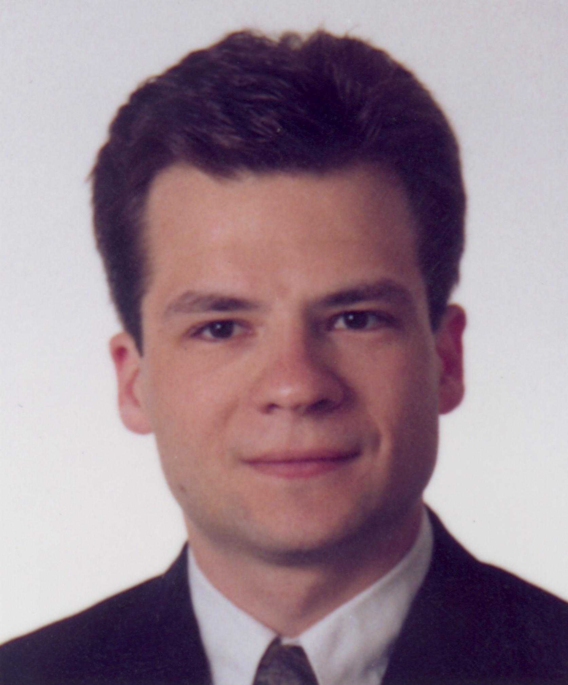

PERSONAL DATA
Nationality : French
Date of birth : December 9, 1974
Marital status : Single

PERMANENT ADDRESS
 3 bis rue de la bergerie
91300 Massy
 Phone : +(33)-06-13-92-23-27
 E-mail : duclap@iname.com

INTERESTS
Hobbies :
1996/1998 : E.M.A. (Massy Africa Exchanges). Organisation of meetings in high schools and youth district centers. Main goal : Make the youth more aware of African problems

1996/97 : Vice-president of EFFOR
'Junior Entreprise' specialised in computer and electronic training. EFFOR is doing more than 700 days of training days and a turnover of 1,2 MF

1995 : R.A.G.E. participation
Humanitarian expedition to west Africa which lasts two months. Total amount of the sponsorship : 2 million of francs

Sport :
1981/99 : Fencing
- 18 years of practice : 131st in France. Involvement in international competition
- Monitor and referee diploma
- Manage the competition committee of the Massy fencing club

EDUCATION
1998 - 1999 : HEC School of Management, Jouy en Josas, France
Specialised Masters degree in Intelligence Marketing
1997 - 1998 : Lund Institute of technology, Lund, Sweden
Last year of engineering school thanks to the ERASMUS program
1993 - 1997 : Ecole Française d’Electronique et d’informatique, Paris, France
The French school of electronics and computer science (EFREI) is a high-ranking private school of engineering whose purpose is to form engineers who are capable of mastering a wide range of engineering subjects and applications in electronics and computer science
ADDITIONAL
1999 : ALCATEL CGA TRANSPORT, Brétigny sur Orge, France
(4 months) World-wide market research about wireless rail automations and development of the business plan
1998 : ERICSSON MOBILE COMMUNICATIONS, Lund, Sweden
(7 months) Development of a test system for a new radio communication system which works at 2.4 GHz
1996 - 1997 : EFFOR, Villejuif, France
Trained staff on Winword 7, Excel 7 and MS-Project at firms like GEC-Alsthom, OTIS and CCF
1996 : CYBERNETIX GROUP, Orsay, France
(3 months) 800-person company developing robotics
Construction of an electronic card which pilots a mine sweeper
1995 : EAU-VIVE, Ouagadougou, Burkina-Faso
(1 month) O.N.G. which acts mainly in Burkina-Faso
Realised a data base under works in collaboration with the Burkina-Faso government
1994 : TECHNICATOME, Saclay, France
(1 month) 900-person company specialised in the nuclear field
Supervised the functioning of the network and computers
TECHNICAL SKILLS
Computer science
Operating system : Dos, Windows, Novell and Unix
Programming languages : C++, Visual Basic, Turbo Pascal, Assembler
Software : SPSS, Mathlab, Winword, Excel, Powerpoint, Lotus 123, Access, MS-Project, Publisher
Electronics
Analogical and digital functions.
Programming PAL, radio-electronic, digital communications, optical fibre, acoustics, automatic
Programming languages : VHDL, PLM51, Assembler 68000, HC11 and DSP in the TMS320C54x family
Software : Pspice, Orcad, Eagle, Viewlogic, Labview

LANGUAGES
French : mother tongue
English : fully fluent
Swedish : Average

